CBY 240 5-2 Lab Worksheet
Andree Salvo
Southern New Hampshire University
CYB 240-13711
Instructor: Brian Remson

Lab: Command Injection
Prompt | Response
In the lab section “Adding the Code,” Step 3, insert your name as a comment after the </html> tag. The line of syntax to put a comment in the file is <!-- YourName -->. Take a screenshot after Step 3. | 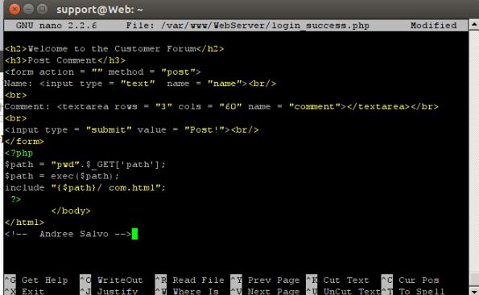
In the lab section “Remote Shell,” Step 17, insert your name at the command line below the output and include it in your screenshot. | 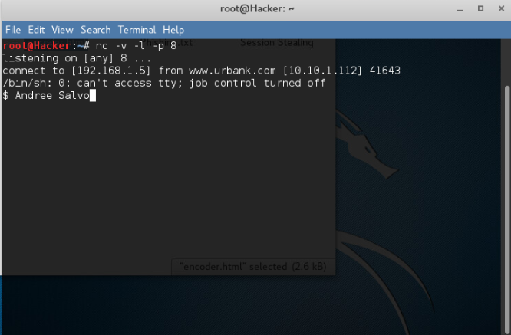
PHP is an interpreted language that does not need to be compiled. What are the dangers of using an interpreted language versus a compiled language? | Interpreted languages, such as PHP, expose source code, run slower, and are more prone to runtime errors and injection attacks than compiled languages.

Lab: Exploiting a Vulnerable Web Application
Prompt | Response
In the lab section “Post Exploitation,” Step 42, insert your last name as the file name instead of “pass”. Make sure you use the file name in Steps 43–45. Take a screenshot after Step 46. | 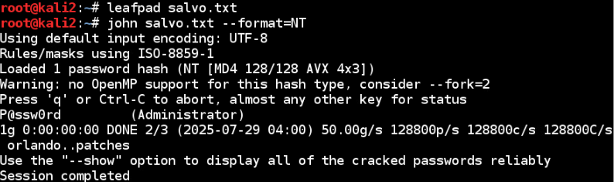
Within the lab, you experienced Armitage, a graphical software package that can be used to carry out Metasploitable activities. The exploit that is targeted is a vulnerability with XAMPP. Explain what the vulnerability is and why it needs to be mitigated. | The XAMPP WebDAV vulnerability enables remote code execution, making it crucial to disable or secure WebDAV to prevent a complete system compromise.

